DIGITAL DESIGN USING HDL LABORATORY (UE18EC206)

EXPERIMENT-8

SIMULATION AND FPGA IMPLEMENTATION OF LATCHES AND FLIP-FLOPS USING XILINX VIVADO TOOL

Aim: Write a Verilog code for the following

D LATCH
module dlatch(e, d, q);
input e;
input d;
output q;
reg q;
always @(e or d)
begin
if (e)
q<=d;
end
endmodule

TEST BENCH
module dlatcht_b;
reg e;
reg d;
wire q;
dlatch uut (.e(e),.d(d),.q(q) );
initial
begin
d = 0;
e = 0;
end

always #3 e=~e;

always #5 d=~d;

initial
#1000 $stop;
endmodule

Simulation Waveform

Report Utilization Summary

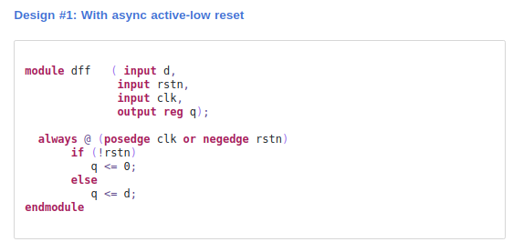
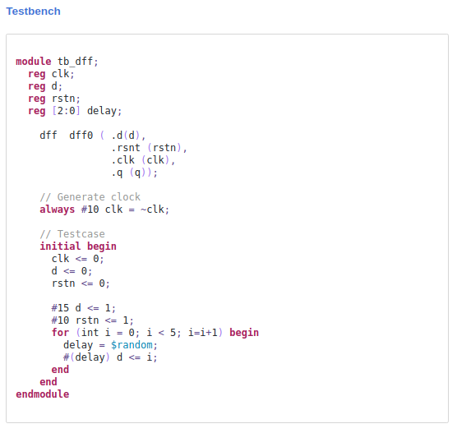

Simulation Waveform

Report Utilization Summary

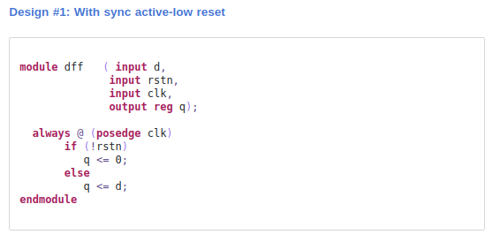
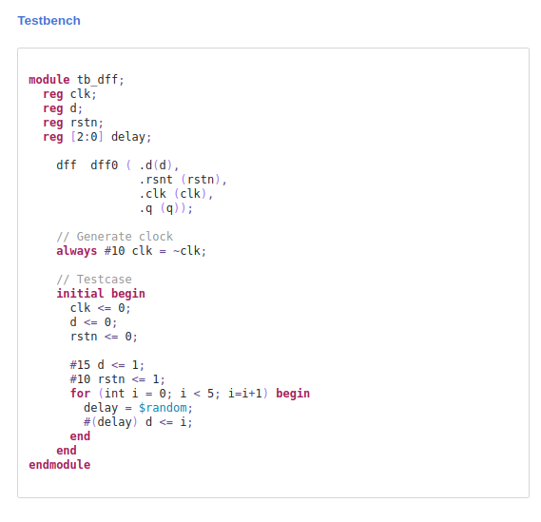

Simulation Waveform

Report Utilization Summary

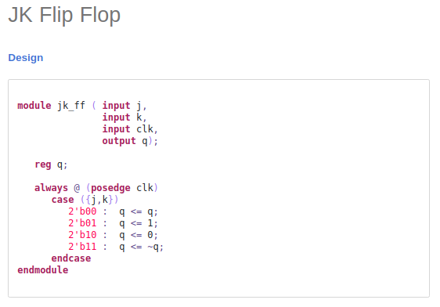
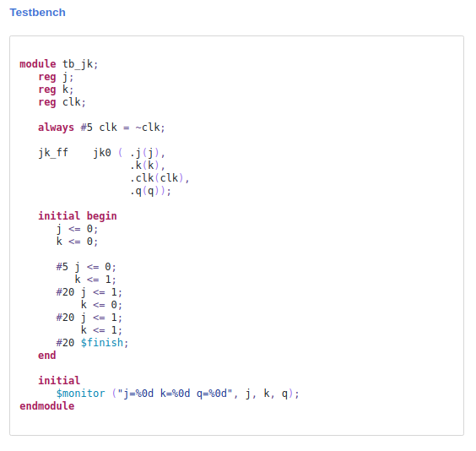
Simulation Waveform

Report Utilization Summary

